|  |
| --- |
|  |
| Project 1A & 1B |
| **SuperNova** |
| Version #1.0  All work Copyright © 2013 by PH.D MEDIA.  All rights reserved. |
| **Brandon Carnell** |
|  |

|  |
| --- |
| August 15th 2013 |

**Table of Contents**

Page 1 – Title

Page 2 – Table of Contents

Page 3 – Version History

Page 4 - Game Overview, Game Play Mechanics, Camera, Controls, Saving and Loading

Page 5 – Interface Sketches

Page 6 – Menu and screen descriptions

Page 7 – Menu and screen descriptions (cont’d),Game World, Levels, Characters

Page 8 – Enemies, Items, Scoring, Sound Index, Art / Multimedia Index

Page 9 - Art / Multimedia Index (cont’d), Author’s Notes

**Version History**

Github: <https://github.com/CarnellB/IntroToGraphics/tree/master/Assignment%204%20-%20SuperNova>

SuperNova_0.1 - Initial Creation, player sprite added

SuperNova_0.2 - gem sprite added

SuperNova_0.3 - rock sprite added

SuperNova_0.4 - parallax background added

SuperNova_0.5 - music added

SuperNova_0.6 - collisions and multiple enemies added

SuperNova_0.7 - scoring and internal documentation added

SuperNova_0.8 - intro screen added

SuperNova_1.0 - Updated most sprites with animations. Splash screen was added. Levels increment but Rock enemy has infinite loop problem

1. **Game Overview**

*The goal of the game is to get the highest score that you can possibly get. Score goes up by collecting gems and dodging rocks.*

1. **Game Play Mechanics**

*You play as a spaceship flying through space. You can collect the red gems to increase your score by a certain amount, depending on the level. Avoid hitting the asteroids, as if you are hit 5 times, the game ends. Every second your score goes up by 10.*

1. **Camera**

*The camera is set to be the right side of the space ship.*

1. **Controls**

*The only controls are moving the mouse to move the ship, clicking on the instruction screen to start, and hitting q to quit on the instruction screen.*

1. **Saving and Loading**

*The game remembers the last score you had before retrying. If you are playing for the first time this will be 0.*

1. **Interface Sketch**

*Intro Wireframe:*

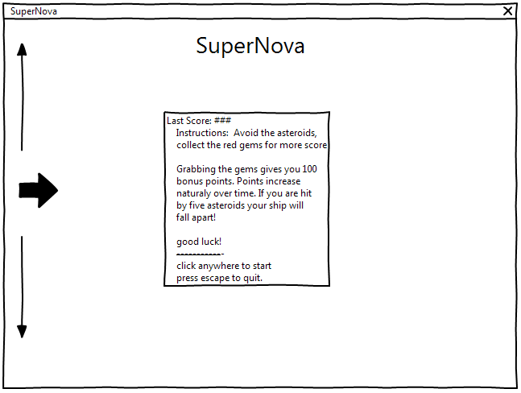

*Gameplay Wireframe:*

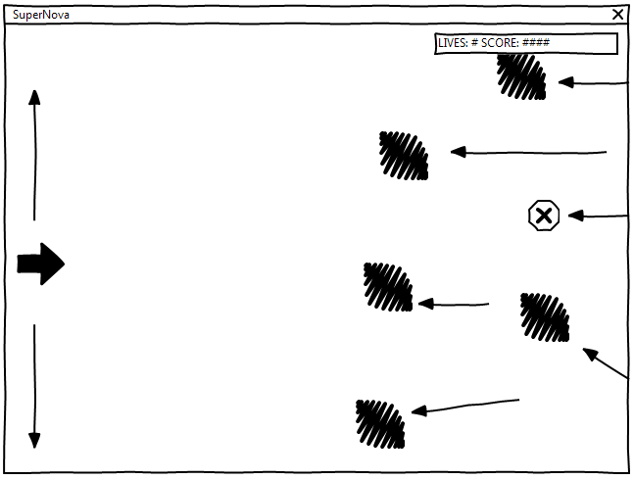

1. **Menu and Screen Descriptions**

*Splash screen:*

**

*Initial Intro screen:*

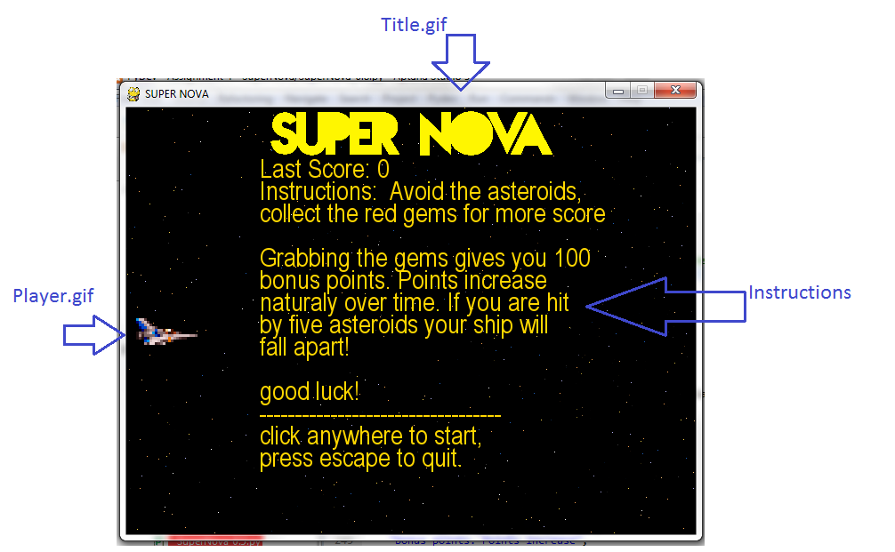

*Gameplay screen:*

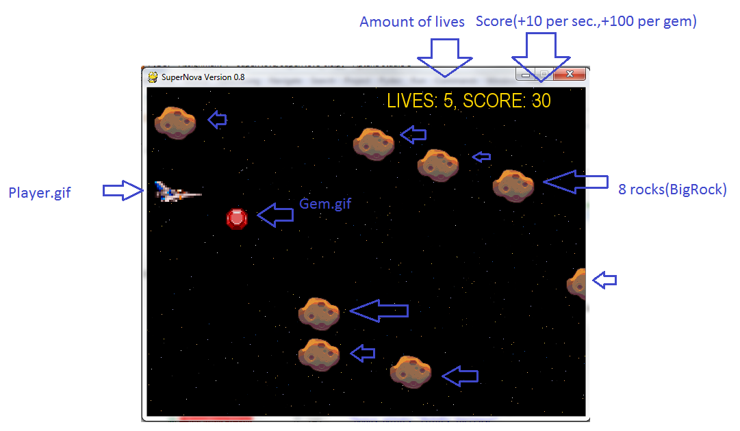

*Post – death screen:*

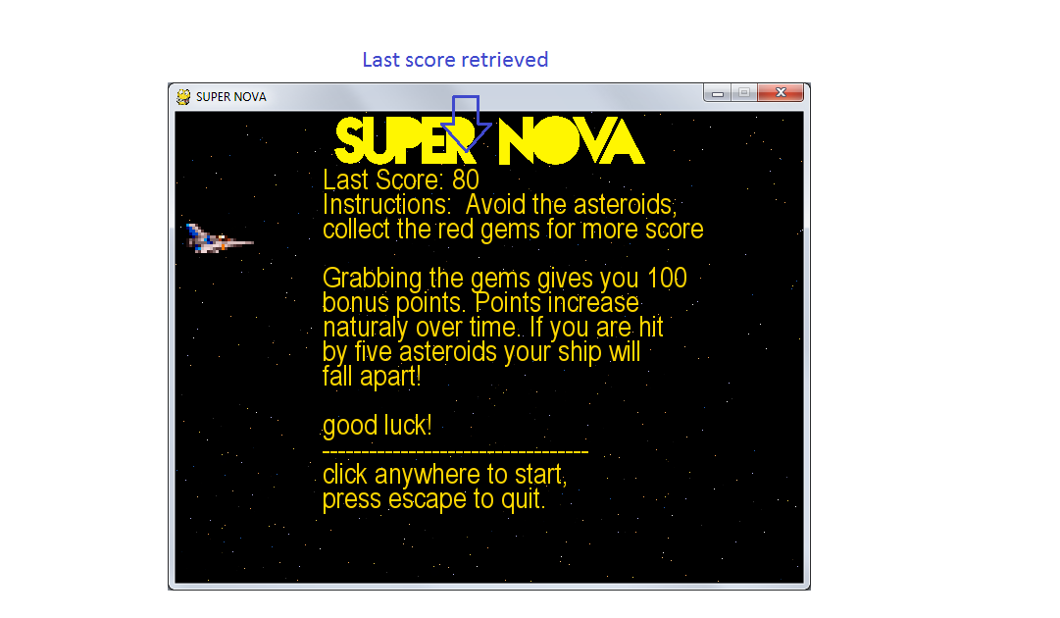

1. **Game World**

*There isn`t much of a world, only endless space, gems, and asteroids.*

1. **Levels**

*The levels increase after the score has gone up to a certain point. You start at level 1 and the game slowly gets tougher the better you do or the longer you play.*

1. **Characters**

*C:\Users\Owner\Dropbox\Github\IntroToGraphics\Assignment 4 - SuperNova\Player.gif - The main players Spaceship, No weapons, and can survive hitting 5 Asteroids. Its only job is to collect red gems.*

1. **Enemies**

*C:\Users\Owner\Dropbox\Github\IntroToGraphics\Assignment 4 - SuperNova\BigRock.gif - Endless Asteroids, some fly straight, others at a small angle. Varies in speed from very slow to very fast. 8 Spawn at the beginning of the game.*

1. **Items**

*C:\Users\Owner\Dropbox\Github\IntroToGraphics\Assignment 4 - SuperNova\Gem.gif - The endless flying Gems. Each are worth 100 points, they move rather slowly.*

1. **Scoring**

*The score goes up by 10 per second that you are alive, and 100 per gem you collect.*

1. **Sound Index**

*BGM.ogg - The never ending boopin’ in the background. Very Spacey*

*Gem.ogg - The jingle that plays when you collect a gem*

*Hit.ogg - The crunchy noise that happens when you accidentally hit an asteroid.*

1. **Art / Multimedia Index**

*BGM.ogg*

*Gem.ogg*

*Hit.ogg*

*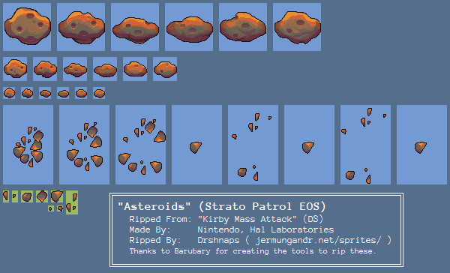 RockSheet.gif*

*C:\Users\Owner\Dropbox\Github\IntroToGraphics\Project 1A\GemSheet.png*

*GemSheet.gif*

*C:\Users\Owner\Dropbox\Github\IntroToGraphics\Assignment 4 - SuperNova\Player.gif Player.gif*

*C:\Users\Owner\Dropbox\Github\IntroToGraphics\Assignment 4 - SuperNova\Title.gif Title.gif*

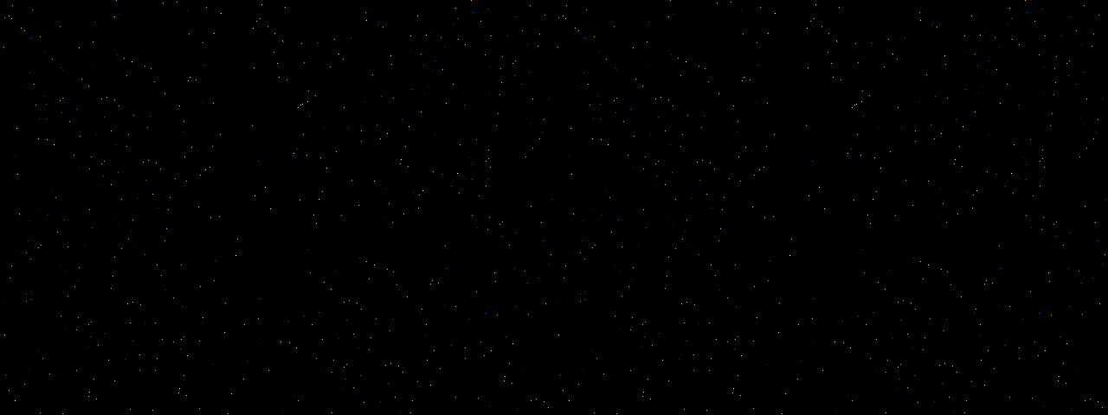

*Space.png (Parallax)*

**

*Splash.png*

**Author’s Notes**

*The sprites / music used in this game come from the following:*

*Player.gif – Gradius*

*GemSheet.gif – Sonic the Hedgehog*

*RockSheet.gif – Kirby Mass Attack*

*Space.png – Edited from Final Fantasy IV*

*Splash.png – Made by a friend (Zak Summerton)*

*BGM.ogg – Megaman Anniversary Collection*

*Hit.ogg – Super Mario Bros.*

*Gem.ogg – Sonic the Hedgehog*